**A**

**Project Report**

**On**

**Forest Fire Prevention System**

**Submitted by**

***Aditya Kumar Pan [210510126018]***

***Het Shah [210510126027]***

***Yavisth Panchal [210510126019]***

**as**

**Partial fulfilment of Semester V**

**Bachelor of Science in Information Technology**

**for A.Y. 2023-2024**

**Under the Guidance of**

**Assist. Prof. Hardik Parmar**

**Submitted To**

**Parul Institute of Computer Application,**

**Faculty of IT & Computer Science**

**Parul University**





PARUL INSTITUTE OF COMPUTER APPLICATION

**CERTIFICATE**

This is to certify that ***Aditya Kumar Pan, Het shah, Yavisth Panchal*** the student(s) of Parul Institute of Computer Application, has/have satisfactorily completed the project entitled “***Forest Fire Prevention System****”* as a part of course curriculum in BCA / BSCIT semester-V for the academic year 2023-2024 under guidance of ***Assist. Prof. Hardik Parmar.***

Enrolment Number: 210510126018

Enrolment Number: 210510126027

Enrolment Number: 210510126019

|  |  |  |
| --- | --- | --- |
| **Quality of work** | **Grade** | **Sign of Internal guide** |
| **Poor / Average / Good /**  **Excellent** | **B /B+ / A / A+** |  |

Date of submission:

HOD, Principal,

**Dr. Hina Chokshi** **Dr Priya Swaminarayan**

**Acknowledgement**

*The success and final outcome of this project required a lot of guidance and assistance from many people and we are extremely privileged to have got this all along the completion of our project. All that we have done is only due to such supervision and assistance and we would not forget to thank them.*

*We respect and thank Dr Priya Swaminarayan, Dean, FITCS for providing us an opportunity to do the project work in BCA and giving us all support and guidance, which made us complete the project duly. We are extremely thankful to Mam for providing her support and guidance, although she had busy schedule managing the academic affairs.*

*We would not forget to remember Prof. Hina Chokshi, HOD, BCA department for her encouragement and more over for her timely support and guidance till the completion of our project work.*

*We owe our deep gratitude to our project guide Prof. Hardik Parmar, who took keen interest on our project work and guided us all along, till the completion of our project work by providing all the necessary information for developing a good system.*

*We are thankful to and fortunate enough to get constant encouragement, support and guidance from our Parents, all Teaching staffs of BCA Department which helped us in successfully completing our project work. Also, we would like to extend our sincere esteems to all staff in laboratory for their timely support.*

***Aditya Kumar Pan [210510126018]***

***Het shah [210510126027]***

***Yavisth Panchal [210510126019]***

**INDEX**

|  |  |
| --- | --- |
| **Content** | **Page No** |
| Abstract | 1 |
| 1. Research | 2 |
| 1.1 Project Research | 2 |
| 1.2 Tools and Technologies used | 2 |
| 1.3 Limitations of the System | 2 |
| 1. Feasibility Study | 3 |
| 2.1 Technical Feasibility | 3 |
| 2.2 Economic Feasibility | 3 |
| 2.3 Operational Feasibility | 3 |
| 1. System Requirement Specifications | 4 |
| 3.1 Introduction to System Requirement | 4 |
| 3.2 System Users | 4 |
| 3.3 Software/ Hardware Requirement | 5 |
| 1. Flow Chart | 6 |
| 1. Timeline Chart | 7 |
| 1. Use Case Diagram | 8 |
| 1. Context Level | 9 |
| 1. Level 1 DFD | 10 |
| 1. Level 2 DFD | 11 |
| 9.1 Level 2.1 DFD | 11 |
| 9.2 Level 2.2 DFD | 12 |
| 1. Class Diagram | 13 |
| 1. Activity Diagram | 14 |
| 1. E-R Diagram | 15 |
| 1. Sequence Diagram | 16 |
| 1. System Flow Diagram | 17 |
| 1. Data Dictionary | 18 |
| 15.1 Description of Data Dictionary | 19 |
| 1. Form Design (Screenshots) | 20 |
| 16.1 Development Phase I | 20 |
| 16.2 Development Phase II | 21 |
| 1. What is Testing? | 22 |
| 17.1 Importance and Types of Testing | 22 |
| 1. Future Enhancements | 23 |
| 1. References and Bibliography | 24 |

**Abstract**

Every year forest fires destroy a huge area of forest cover, leaving large-scale destruction of flora and fauna in its wake. Forest fires play a major role in driving thousands of species of wildlife to extinction year. Artificial intelligence helps us predict the future and using it in this domain can successfully help us predict forest fires and save wildlife. Any fire essentially depends upon 3 factors which are oxygen, temperature, and humidity. This project aims at predicting the possibility of a forest fire taking place, given the oxygen, humidity, and temperature content of a given place. A concept website that can be created to take inputs from the user and predicts the forest fire probability in real-time, is also shown.

1. **Research**

**1.1 What is research?**

Every year forest fires destroy a huge area of forest cover, leaving large-scale destruction of flora and fauna in its wake. Forest fires play a major role in driving thousands of species of wildlife to extinction year. Artificial intelligence helps us predict the future and using it in this domain can successfully help us predict forest fires and save wildlife.

* 1. **Tools and Technology Used:**

**Technology:** HTML, CSS, Python, FLASK (A microweb framework that integrates web applications with any python program).

**Hardware:** Device with basic Operating system such as Linux or windows, CPU, GPU and minimum 2GB of storage and memory (RAM).

**Software:** This software does not require a particular Operating System (Windows, Mac, Linux, etc.) to run but only a web browser and internet connection because it is a web application.

* 1. **Limitation of System:**

**Data Accuracy and Availability:** The effectiveness of a forest fire prevention system heavily relies on the quality and availability of data. Inaccurate or incomplete data, such as outdated weather information or inaccurate fire risk assessments, can impact the system's ability to make accurate predictions and recommendations. Limited data sources or gaps in data coverage can also hinder the system's capabilities.

**Uncertainty in Fire Behavior:** Forest fires are dynamic and complex events, and predicting their behavior with absolute certainty is challenging. Fire behavior can be influenced by numerous factors, including topography, vegetation type, wind patterns, and human intervention.

1. **Feasibility Studies**

* **What is Feasibility?**

Feasibility refers to the evaluation and analysis of whether a project is technically, economically, and operationally viable. It involves assessing the project's potential to be successfully completed within the specified constraints, such as time, budget, resources, and desired outcomes.

**2.1 Technical Feasibility: -**

This assessment focuses on the technical resources available to the organization. It helps organizations determine whether the technical resources meet capacity and whether the technical team is capable of converting the ideas into working systems. Technical feasibility also involves the evaluation of the hardware, software, and other technical requirements of the proposed system. As an exaggerated example, an organization wouldn't want to try to put Star Trek's transporters in their building- currently, this project is not technically feasible.

* 1. **Economic Feasibility: -**

This assessment typically involves a cost/ benefits analysis of the project, helping organizations determine the viability, cost, and benefits associated with a project before financial resources are allocated. It also serves as an independent project assessment and enhances project credibility-helping decision-makers determine the positive economic benefits to the organization that the proposed project will provide.

* 1. **Operational Feasibility: -**

Determine the viability, cost, and benefits associated with a project before financial resources are allocated. It also serves as an independent project assessment and enhances project credibility-helping decision-makers determine the positive economic benefits to the organization that the proposed project will provide.

**3. System Requirement Specification**

**3.1 Introduction To SRS.**

**3.1.1 What is SRS?**

A software requirements specification (SRS) is a description of a software system to be developed. It lays out functional and non-functional requirements, and may include a set of use cases that describe user interactions that the software must provide.

* + 1. **Need of SRS**

In order to fully understand one’s project, it is very important that they come up with a SRS listing out their requirements, how are they going to meet it and how will they complete the project. It helps the team to save upon their time as they are able to comprehend how are going to go about the project. Doing this also enables the team to find out about the limitations and risks early on.

**3.2 System Users:**

1. **System Administrators**: These individuals are responsible for installing, configuring, and maintaining the forest fire prevention system.
2. **Data Managers:** Data managers handle the collection, storage, and organization of the data used in the system. They ensure that the system has access to up-to-date and accurate information about weather conditions, fire hazard levels, temperature, humidity and oxygen level.
3. **Firefighters:** Firefighters are the primary end-users of the forest fire prevention system. They rely on the system to receive real-time information about fire incidents, fire behaviour, and the optimal strategies for fire suppression.

**3.3 Hardware / Software Requirement**

**3.3.1 Hardware Requirement**

|  |  |
| --- | --- |
| **Name of Components** | **Specification** |
| Processor | Intel core i5 or more |
| RAM | 4 GB RAM or more |
| Hard Disk | 256 / 512 GB or more |

**3.3.2 Software Requirement**

|  |  |
| --- | --- |
| **Name of Components** | **Specification** |
| Operating System | Windows 7 or more |
| Software development Kit | Google Chrome |
| Tools & languages | HTML, CSS, Python |

**4. Flow Chart**

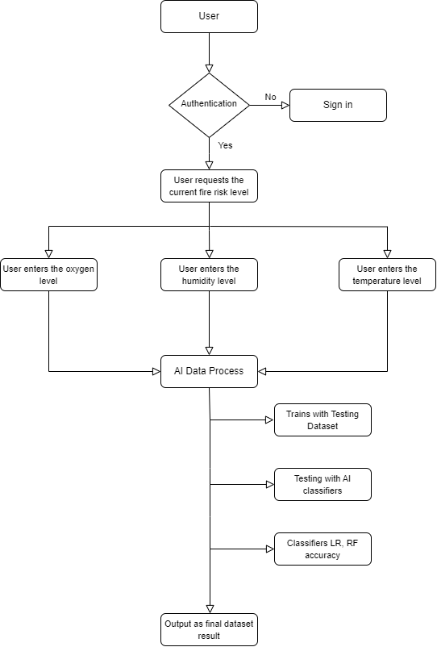

Figure 4. Flow Chart

**5. Timeline Chart**

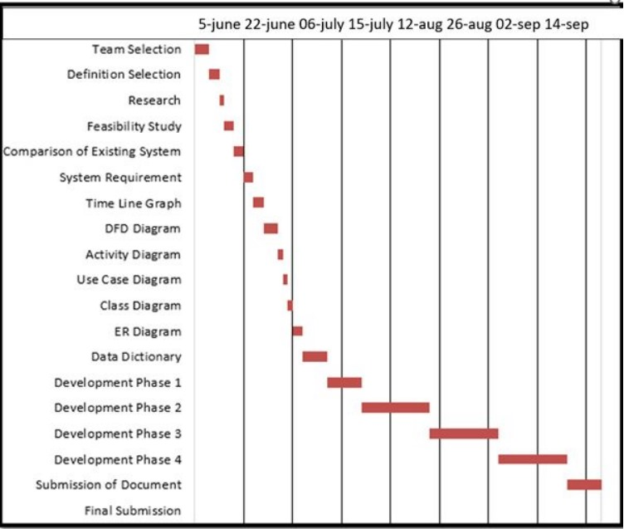

Figure 5. TimeLine Chart

**6. Use-case Diagram**

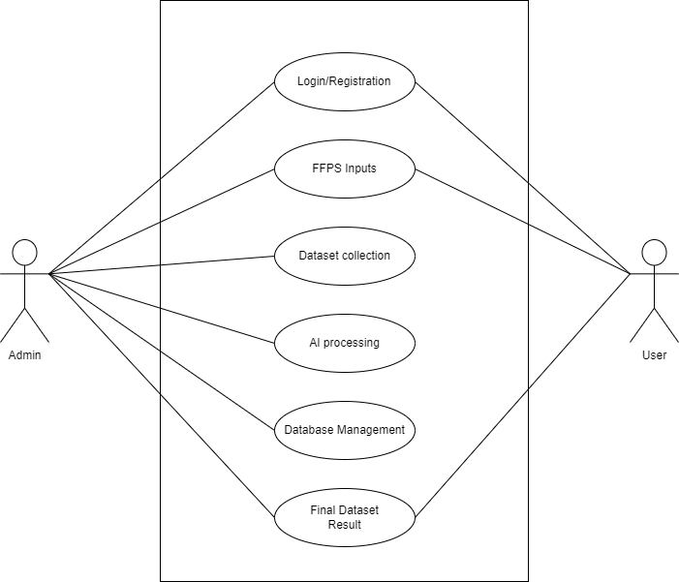

Figure 6. Use Case Diagram

**7. DFD 0 Level Diagram**

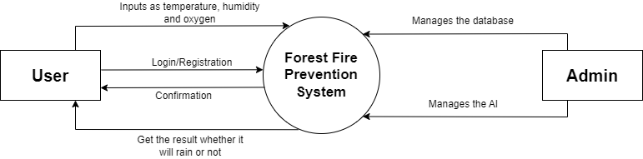

Figure 7. DFD 0 Level Diagram

**8. DFD 1 Level Diagram**

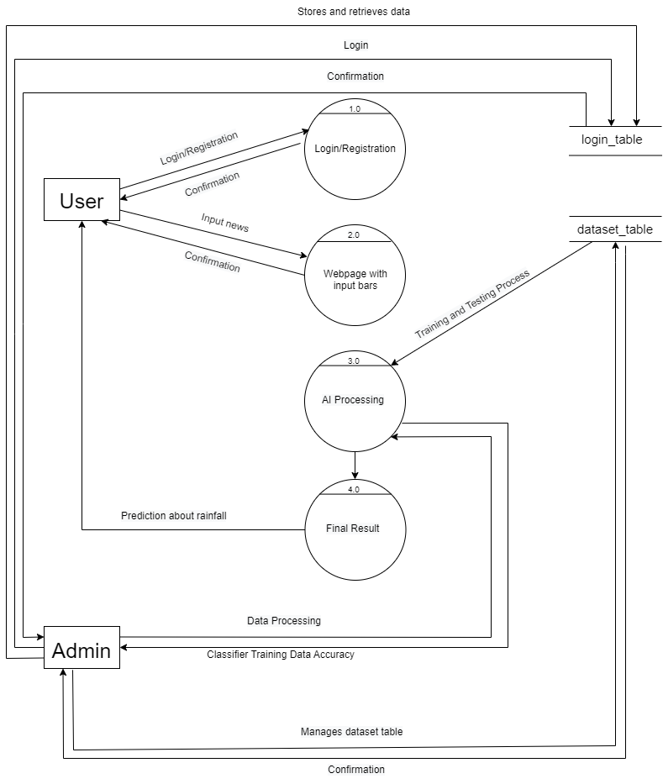

Figure 8. DFD 1 Level Diagram

**9.1 DFD 2.1 Level Diagram**

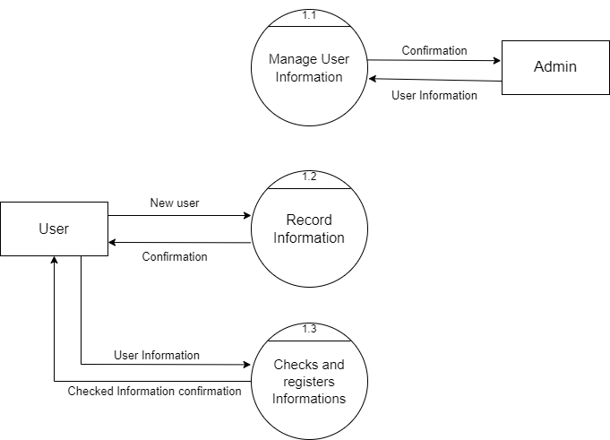

Figure 9.1 DFD Level 2.1 Diagram

**9.2 DFD 2.2 Level Diagram**

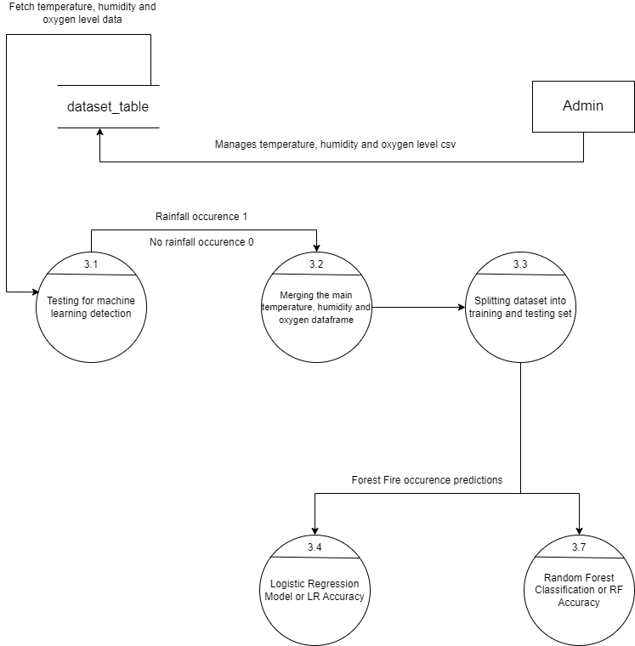

Figure 9.2 DFD Level 2.2 Diagram

**10. Class Diagram**

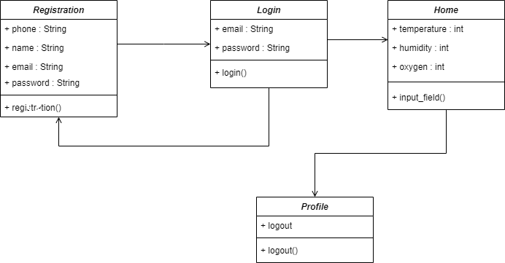

Figure 10. Class Diagram

**11. Activity Diagram**

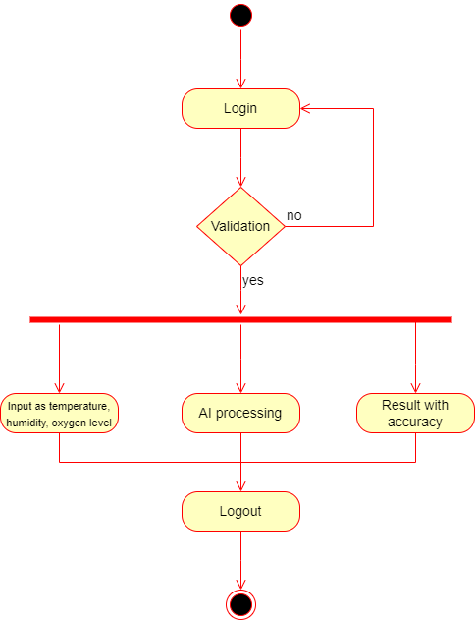

Figure 11. Activity Diagram

**12. E-R Diagram**

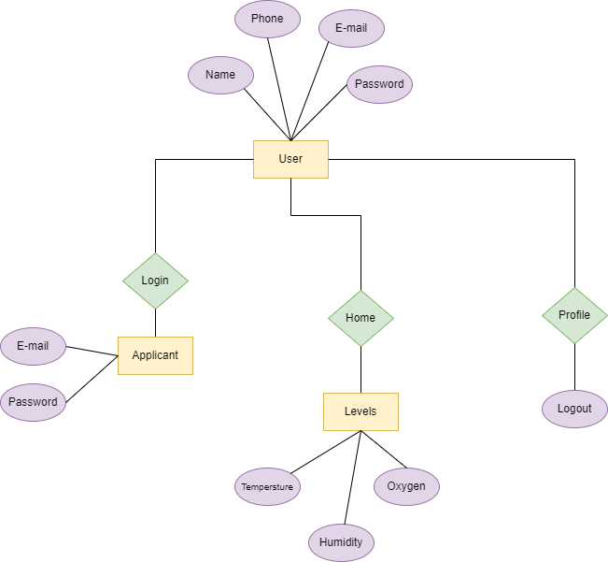

**13. Sequence Diagram**

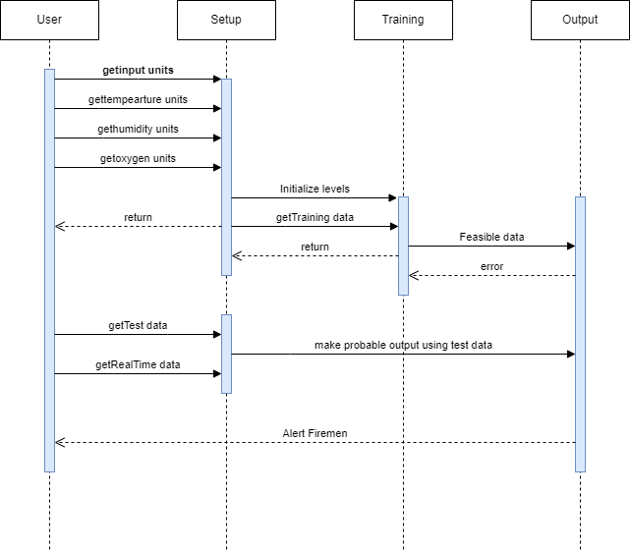

Figure 13. Sequence Diagram

**14. System Flow Diagram**

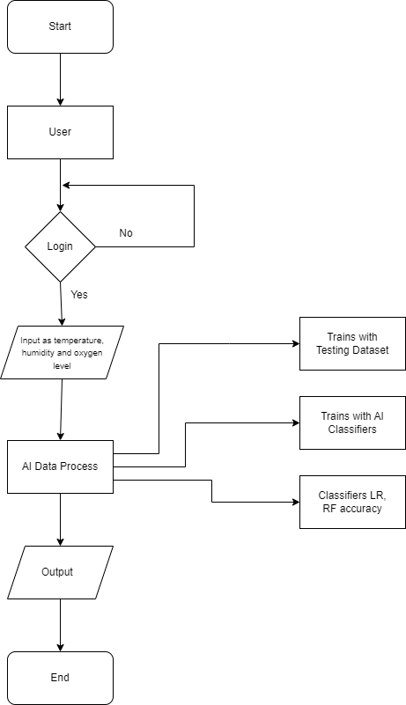

Figure 14. System Flow Diagram

1. **Data Dictionary**
2. **Admin:**

**Table Description: Login**

|  |  |  |  |  |  |  |
| --- | --- | --- | --- | --- | --- | --- |
| **Sr. No** | **Field Name** | **Datatype** | **Size** | **Description** | **Constraint** | **Example** |
| 1 | username | varchar | 256 | Username of the User | NOT NULL | admin |
| 2 | password | varchar | 8 | Password of the User | NOT NULL | password |

Figure 15. Data Dictionary

**15.1 Description of Data Dictionary**

A data dictionary is a structured list of the data elements, tables, fields, and relationships within a database or information system. It provides a clear and concise description of the various elements in a database, including their data types, allowed values, and relationships with other elements.

The purpose of a data dictionary is to provide a single, authoritative source of information about the data in a system. It is typically used by database administrators, developers, and other stakeholders to understand and document the structure and content of a database.

A typical data dictionary includes tables or lists of all the data elements or entities in a system, along with their attributes or fields. Each field is described in detail, including its data type, size, format, and other relevant characteristics. The data dictionary may also provide information on the relationships between tables, such as foreign keys or other constraints.

1. **Form Design (Screenshots Phase 1 ,2 & validation’s screenshots)**

**16.1. Development Phase -1**

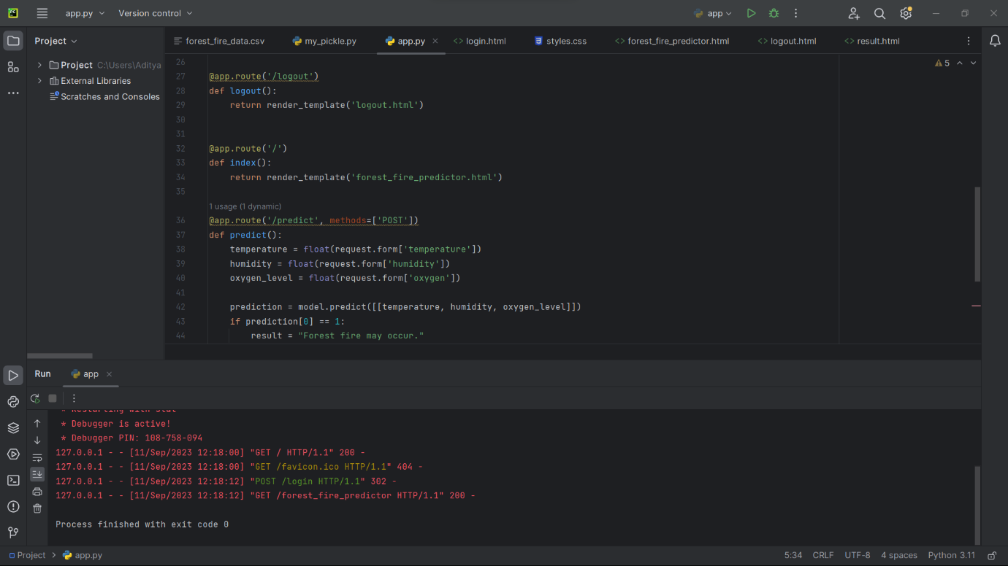

Fig 16.1 Development Phase I

Code for python model using Flask

**16.2. Development Phase -2**

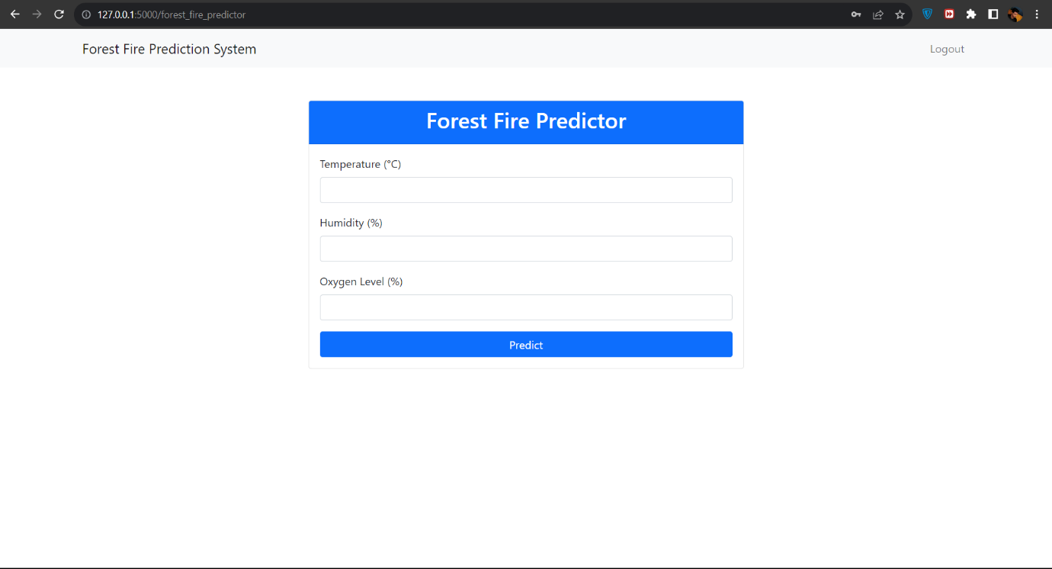

Fig 16.2 Development Phase II

Front-end display of the FFPS System

1. **What is testing?**

**17.1. Importance and types of testing**

Testing in software engineering is the process of evaluating a system or its component(s) with the intent to find whether it satisfies the specified requirements or not. It helps to identify any defects, bugs or gaps in the requirements that may have been missed during the development phase.

Testing is an important aspect of software development as it helps to ensure that the software behaves as expected and is free of defects. There are several types of testing that are commonly used, including:

Unit testing: This type of testing focuses on individual units or components of the software. Unit tests are usually written by developers and are used to test the functionality of specific code segments.

Integration testing: This type of testing focuses on testing the integration of different components of the software. Integration tests are used to verify that the different components of the software work together as expected.

Functional testing: This type of testing focuses on testing the software's functionality as a whole. Functional tests are used to verify that the software meets its specified requirements.

Performance testing: This type of testing focuses on testing the software's performance and scalability. Performance tests are used to measure the software's performance under different loads and conditions.

Acceptance testing: This type of testing focuses on determining whether the software is acceptable for release. Acceptance tests are typically carried out by the customer or end-user.

Regression testing: This type of testing focuses on ensuring that changes made to the software do not introduce new defects or break existing functionality.

Overall, testing helps to identify and fix defects early in the development process, which can save time and money. It also helps to ensure that the software meets the needs of the customer and is of high quality.

**18. Future Enhancement**

Advanced Data Integration: Enhancements can be made to integrate a wider range of data sources. This can provide a more comprehensive and up-to-date picture of fire risks and behavior, enabling more accurate predictions and decision-making.

IoT and Sensor Networks: Integrating IoT devices and sensor networks can provide real-time data on various parameters, such as temperature, humidity, wind speed, and moisture levels. This data can be used to monitor environmental conditions and detect anomalies that may indicate fire risks.

Real-time Monitoring and Control Systems: Integration with real-time monitoring and control systems, such as drones and IoT devices, can enable remote monitoring of fire-prone areas. These systems can provide live feeds, aerial imagery, and situational data, allowing for quick response and more efficient resource deployment.

**19. References & Bibliography**

Websites:

* Diagrams: <https://app.diagrams.net>
* Stack Overflow: <https://stackoverflow.com/questions/38207220/python-code-structure-with-flask-integrated>
* GitHub[:https://github.com/nachi-hebbar/Forest-Fire-Prediction-Website/blob/master/Forest_fire.csv](https://github.com/nachi-hebbar/Forest-Fire-Prediction-Website/blob/master/Forest_fire.csv)
* Youtube[: https://www.youtube.com/watch?v=UbCWoMf80PY](:%20https:/www.youtube.com/watch?v=UbCWoMf80PY)